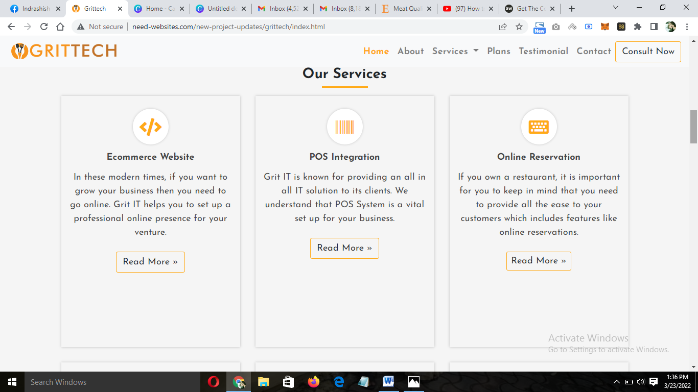

1. I need the texts to be aligned and justified
2. Readmore button should be aligned at the same place

(this is valid for all the boxes)

T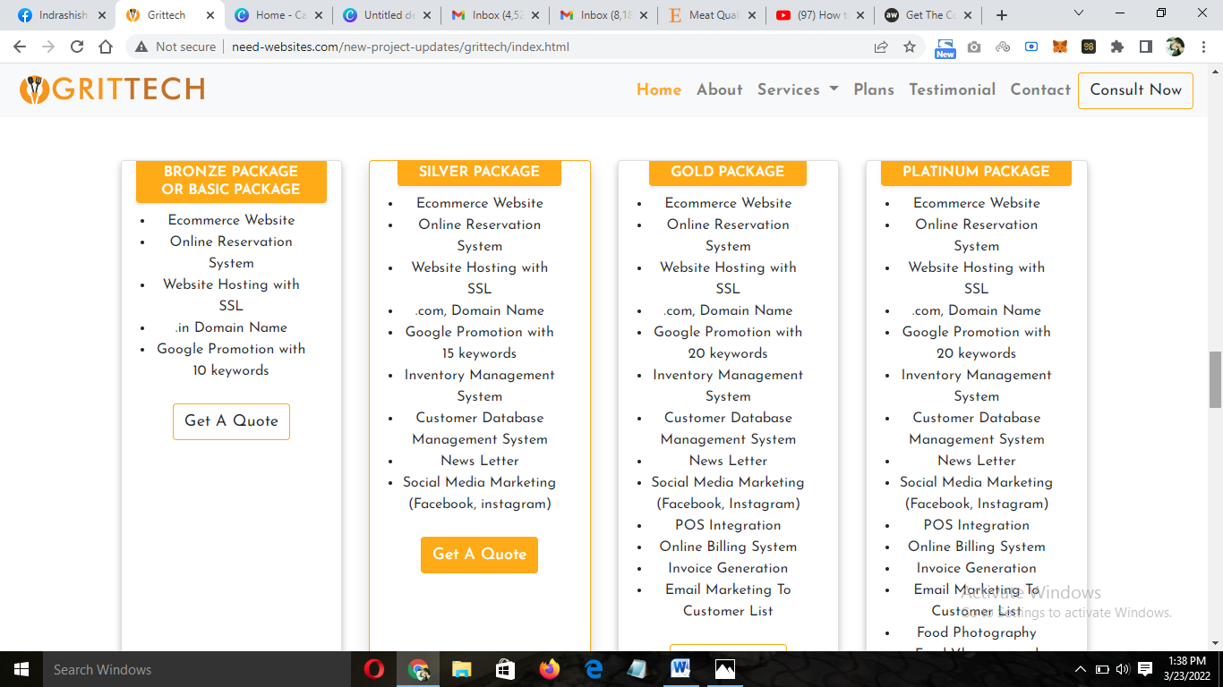

1. Remove Basic
2. Get a Quote should be in the same alignment
3. The boxes with more features should have a read more or know more option clicking which the entire list will open up

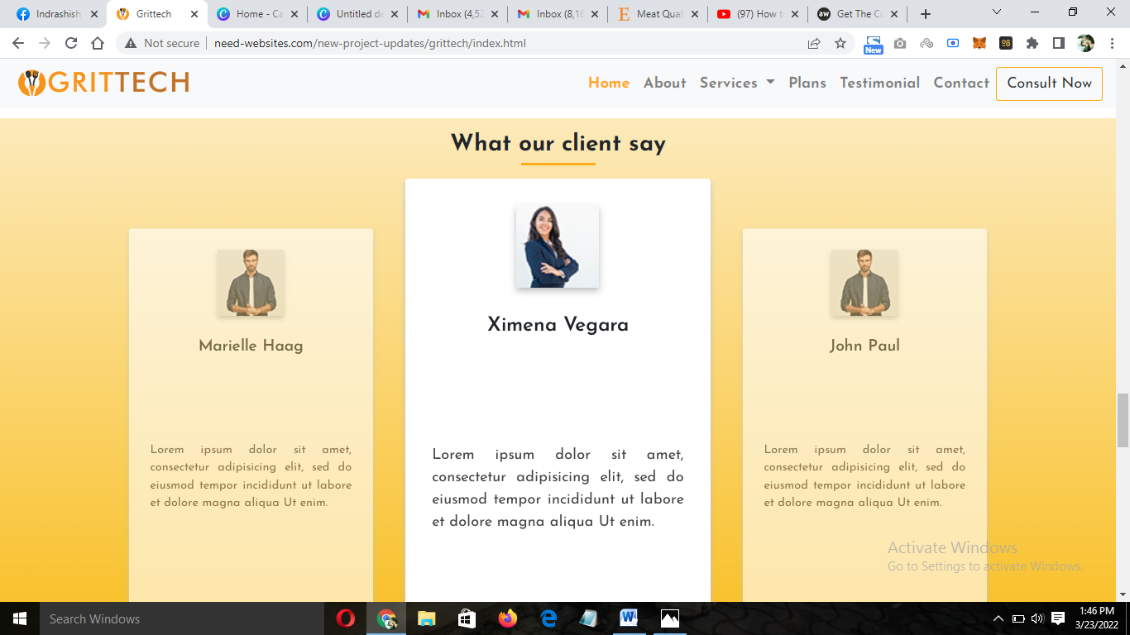

Replace the Testimonial with ‘GRITTECH PARTNERS WITH’ and give the logos of 1. Jabbrr Afghani 2. Mantra Indian Restaurant 3 . Jolly Sailor Restaurant 4. Juice Veda 5. Home Café